CENWP-OD-B 12 July 2024

MEMORANDUM FOR THE RECORD

SUBJECT: 24BON024 MFR CI LPS RB4 and RB5 Pacific Lamprey Mortality

On the morning of 11 July, Project Biologists found one Pacific lamprey mortality in the Cascades Island LPS Rest Box 4 (CI LPS RB4) and one mortality in Rest Box 5 (CI LPS RB5). Both fish were scanned for PIT tags, measured, inspected, and returned to the river.

1) Rest Box 4
- Species – Pacific Lamprey (Entosphenus tridentatus)
- Origin – Unknown
- Length – 62.87cm
- Marks and tags – None
- Marks and Injuries found on carcass – None
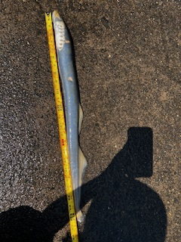
- Cause and Time of Death – Unknown
- Future and Preventative Measures – N/A

2) Rest Box 5
- Species – Pacific Lamprey (Entosphenus tridentatus)
- Origin – Unknown
- Length – 60.96cm
- Marks and tags – None
- Marks and Injuries found on carcass – None, except for part of caudal fin missing.
- Cause and Time of Death – Unknown
- Future and Preventative Measures – N/A

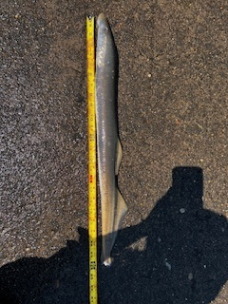

Sincerely,
Project Fisheries

